

**SCHOOL OF ARCHITECTURE, COMPUTING & ENGINEERING**

*BSc in Computer Science*

**Michail Markou**

*CN6003 – COMPUTER AND NETWORK SECURITY*

**UEL NUMBER**

*2020732*

***Date***

11/11/2021

**Network Protocol Analyzers in short**

Michail Markou

University of East London

Contents

1. Abstract 1

2. Introduction 1

3. Security tools 1

3.1. Wireshark 1

3.1.1. History 1

3.1.2. Use Cases & Drawbacks 2

3.2. TCPdump 2

3.2.1. History 2

3.2.2. Use Cases & Drawbacks 3

3.3. Compare Results 3

4. Real Case Research Analysis Literature Review 4

4.1. The case Study 4

4.1.1. The Problem Approach technique 4

4.1.2. Round One 4

4.1.3. Round Two 5

4.1.4. Narrowing the scope 5

4.1.5. Lessons & Answers 5

References 6

Appendix 7

Information sources 7

Glossary 7

# Abstract

Network protocol analysis is a technique to provide architects, engineers, constructors, and owner-operators to capture binary-raw data for further analysis by intercepting, sniffing the interface activity of a network card for sustaining infrastructures. We are going to capture and analyze network traffic with 2 different software solutions e.g., tools (Wireshark, tcpdump) and see their use cases and drawbacks of each.

*Keywords*: Network Protocol Analyzers; Software Package; Network Security tools; Network Sniffing;

# Introduction

Network sniffing is intercepted by packet assembly binary format of the original message content in switched and non-switched networks[1]. After capture, the received package is being built to construct the original form from senders’ perspective. Technically if someone get data that way it is considered a security breach of layer 2[2] switched-network [1, 2].

Each tool can be used either ethically or unethically. Capturing the network traffic can be proven very useful on troubleshooting a network security, performance, activity and design as a whole or as individuals[3]. In addition, statistics can be drawn and present themselves via automation in a visualization and monitoring tool (e.g., Nagios)[4].

# Security tools

## Wireshark

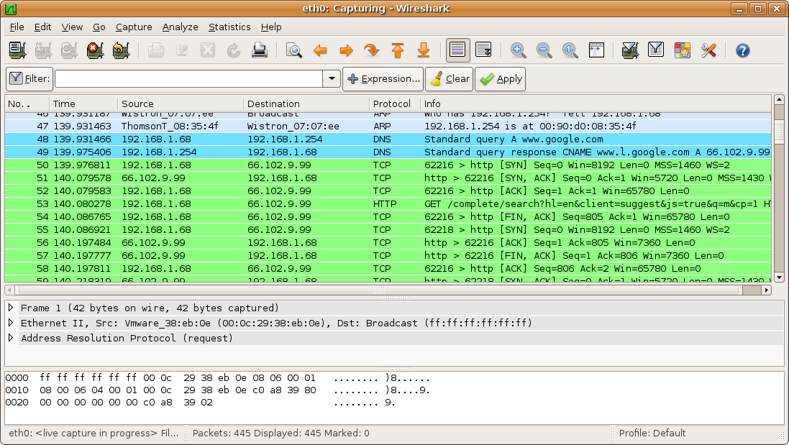

Figure https://el.wikipedia.org/wiki/Wireshark

### History

An open-source [12] industry standard network analyzer either offline or online data store and process for network troubleshooting, analysis, software and communications protocol development and education written in C++ under GPL-2.0+ license. Originally developed in 1998 its know fore flexibility and a nice UI/UX experience GUI approach, available on most standard system platforms e.g., Windows, Linux, MacOs et al [3].

In addition is also available at command line aka tshark.

### Use Cases & Drawbacks

#### Pros [4,5]

* Open-Source
* Flat learning curve (aka It's a walk in the park, simply as sushi) [6]
* GUI tool – Easy
* Packet Analysis & identify and decode data payloads if encryption keys are known
* Advanced Network Interfaces
* Complex Filters (display & capture)[5]
* Can import/read tcpdump files (cross-compatibility)
* It provides decoding of protocol-based packet capturing.
* API testing/troubleshooting

#### Cons

* Filters difficult to remember and formulate.
* ~Intimidating for new Users due to its colors and columns;

#### Usage

Wireshark is being used for troubleshooting the Network either for Network[6] software/hardware faults all the way to security intrusion detection [11] as a help component. With it you can collect and rebuild packets, hear VoIP traffic with sound output, decrypt packet structures you collected[7], and in future decrypt them with secret key input. From a home network, small business to Enterprise Level or educational purpose to understand how protocols traffic interact with you and the Internet.

One major note is Wireshark captures only the hosts interfaces activity meaning you can’t sniff the “entire” broadcast domain/(V)LAN or Network but only what comes to you, a workaround to this to be achieved is you must activate port mirroring aka (x)SPAN protocol on the network device [8].

## TCPdump

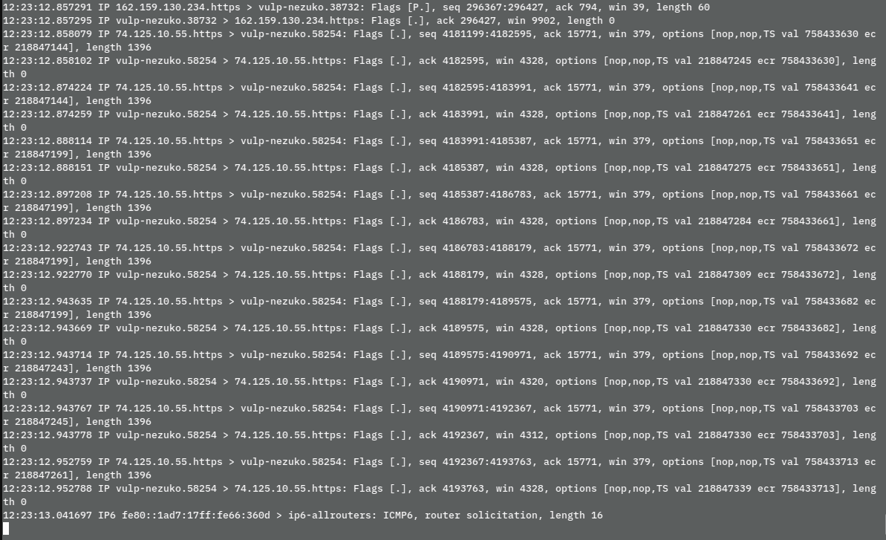

Figure https://en.wikipedia.org/wiki/Tcpdump

### History

An open-source industry standard network analyzer either offline or online data store and process for network troubleshooting, analysis, software and communications protocol development and education. Its intended for more advanced professional users due to its complexity without a GUI, written in C under BSD license. Originally developed in 1988 uses a technical command line interface for data output, available on most standard system platforms e.g., Windows, Linux, MacOs et al [7].

### Use Cases & Drawbacks

#### Pros [4]

* Open-Source
* Filters
* Setup due to CLI (no GUI need to run on server)
* Packet Analysis & simple identify and decoding[8]
* Pre-Installed on most Linux repos by default

#### Cons

* Steep learning curve
* Intimidating CLI experience
* Simple analysis of specific types e.g., DNS queries
* Simple Conventional system-based interfaces

#### Usage

As Wireshark usage does with contrast it cannot be used for VoIP playback “live” or wi-fi decryption mechanisms.

## Compare Results

**Wireshark vs TCPdump**

|  |  |  |
| --- | --- | --- |
| **Criteria** | **Wireshark** | **tcpdump** |
| **Open-Source** | **+** | **+** |
| ***Easy to use*** | **+** | **-** |
| ***Easy to Learn*** | **+** | **-** |
| ***Packet Identification analysis & decode*** | **+** | **-** |
| ***Efficiency decoding*** | **+** | **-** |
| ***Fast setup on host*** | **+** | **+** |
| ***Filters*** | **+** | **-** |
| ***Network Interfaces*** | **+** | **-** |
| ***Cross-Compatibility*** | **+** | **-** |
| ***Flexibility on using live*** | **+** | **+** |
| ***Troubleshooting*** | **+** | **+** |
| ***Data capture abilities*** | **+** | **+** |
| ***Industry Standard*** | **+** | **+** |
| ***Product & Community Support*** | **+** | **+** |

#### **Notes to take**

When comparing products, we have to keep in mind some core things.

If its long enough out there so we can rely to it as a business and adapt it under the umbrella term “industry standard” from its features, the learning curve, the product support and product availability in many forms.

#### **Results**

From above Results we can clearly see that Wireshark is the winner, however tcpdump is the default software bundle package that comes in most Linux Distributions pre-installed and it’s very easy to set it up on a host, capture the data save them and forward them in another host that hosts Wireshark application all of that just using CLI/command line interface. In Contrast tshark which is a CLI version of Wireshark does not come pre-installed.

It is not about which is better but what Design approach we have in mind capturing and analyzing the Data. A common workflow/pipeline in network sniffing is tcpdump -> Wireshark or tshark -> Wireshark because GUI Server Environment is usually not an option and can introduce security vulnerabilities and network consumption bandwidth in higher rates but if you don’t know what you are looking for Wireshark’s GUI is faster and more visually consistent to analyze patterns on the fly because as humans, we can perceive information and analyze it faster when visually we see something more understandable.

# Real Case Research Analysis Literature Review

## The case Study [13]

### The Problem Approach technique

A large Internet Service Provider seeing random failures of a client/s to get IP/register to their IPTV platform service. There are several data sources and not all have a problem.

The majority of clients in the same group meaning they are attached in same LAN L2 switched network can get registered their service but some for strange reason cannot.

### Round One

First step was to look at the Register Server for giving IP’s/registers the service (BRAS), The application’s server sees the DHCP Discover of that individual client we can now know that DHCP Discover was being sent indeed then we look at the client/s logs by achieving this there are 2 procedures.

1. Send a remote engineer to the site
2. Port Mirror the switch port to see IPTV service traffic.

We always follow business flow of resolving an issue. The Engineer at the site gets the logs and ensures proper end consumer L1 is in good integrity state among this he/she makes sure that DHCP DORA process will be active continually that because of nature of DHCP application each failure the client sends the next Request Discover with an additive big delay in producing that packet.

In the logs we found the connection was ‘hanging’ at the application handshake phase and then erroring out. It could not communicate or get any information across the network.

We telnet on top of SSH and connect at the closest Edge node from ISP perspective in our case L3 Switch (not in end user/client itself because Operation engineers doesn’t have the right as law concerns) and we port mirror the traffic using RSPAN to a designed specific node in the network that is being used to capture and analyze traffic using Wireshark without causing bandwidth issues.

### Round Two

We confirm that DHCP Discover was sent indeed. But no offer was seen despite server sending that message.

Somewhere in the middle the packets been dropped. The important point is the server is sending a reply to client/s request without success of receiving it, but why?

### Narrowing the scope

The Client request can be sent all the way to server across the WAN.

The server Responds but just before the Metro Ethernet network the packet disappears.

So, the Next step is to port Mirror/clone traffic from every “child” direction in that graph[9] directly connected or logically connected to the last known Router interface that receives the packets successfully.

Following the path gradually we can reach the reason of a network failure and client dissatisfaction. It Could be a firewall issue that a policy cut its off or even a network misconfiguration with any kind of collision services.

### Lessons & Answers

* Doesn’t matter how big the network is, cut it up in to chunks until you close in on the issue, it is like a shortest-route path algorithm logic, actually this is exactly how an algorithm will work its way through the solution e.g., make neighbors, many times the same way we use to solves agnostic problems[10].
* Trace the problem bottom top in OSI/TCP-IP layer.
* Log the first point of failure
* Log the Last Point of failure
* Repeat
* Wireshark is your friend

# References

[1] https://www.helpnetsecurity.com/2003/12/15/packet-sniffing-on-layer-2-switched-local-area-networks/ accessed: 11th November 2021

[2] Qing-Xiu Wu, The Network Protocol Analysis Technique in Snort, Physics Procedia 25 (2012) 1226 – 1230

[3] https://en.wikipedia.org/wiki/Wireshark accessed: 11th November 2021

[4] https://www.trustradius.com/products/wireshark/reviews?qs=pros-and-cons

[5] Wireshark vs tcpdump, <https://www.educba.com/tcpdump-vs-wireshark/> accessed: 11th November 2021

[6] Learning Curve fun synonyms, <https://forums.anandtech.com/threads/whats-the-opposite-of-a-steep-learning-curve.1838122/> accessed: 11th November 2021

[7] <https://en.wikipedia.org/wiki/Tcpdump> accessed: 11th November 2021

[8] Cisco, SPAN analyzer system, <https://community.cisco.com/t5/networking-documents/understanding-span-rspan-and-erspan/ta-p/3144951> accessed: 11th November 2021

[9] https://mrncciew.com/2014/08/16/decrypt-wpa2-psk-using-wireshark/ accessed: 11th November 2021

[10] https://wiki.wireshark.org/HowToDecrypt802.11 accessed: 11th November 2021

[11] 1.1.8. what Wireshark is not, <https://www.wireshark.org/docs/wsug_html_chunked/ChapterIntroduction.html> accessed: 11th November 2021

[12] 1.1.7. what Wireshark is not, <https://www.wireshark.org/docs/wsug_html_chunked/ChapterIntroduction.html> accessed: 11th November 2021

[13] Case Study Approach, https://sharkfestus.wireshark.org/sharkfest.12/presentations/BI-8b_Wireshark_Software_Case_Studies-Tim_Poth.pdf accessed: 11th November 2021

# Appendix

## Information sources

## Glossary

|  |  |
| --- | --- |
| **Term** | **Definition** |
| Agnostic | Not Depended on the content e.g., no hardcoded |
| Abstraction | A high-Level view of things from the final consumer perspective without knowing too much about its underlying mechanics but still able to use it. |
| DORA | DHCP application process, Discover, Offer, Request, Accept/Ack |
| DHCP | A Server with Dynamic Pool of Internet Addresses for hosts that make A Discover Request. He can also give static IP address via DHCP options (82) recording the corresponding mac to IP reservation. |
| LAN | A Private Local network usually small range in logic. |
| VLAN | Virtual multiple Lan/s on Same Switch. Creates a broadcast domain. |
| By Design and by default | Introduced in Design and applied from the start in pre-production environment (before launch) |

END of File – EOT

If you can see this I have run out of content.

1. Non-switched like a hub which broadcasts the frames to everyone. On the other hand, switched networks have CAM tables which contains MAC addresses, switch-ports and VLAN information in addition checking ARP cache table on host before sending.
2. Despite Security Breach Network Data probably have from application tier perspective (their own) and presentation layer (their own) multi-level encryption nowadays.
3. A proper network must be designed and support (by design and by default) both “proactive”, “reactive” concepts.
4. It is widely used as industry standard from home office, small business to Large Enterprises and organizations such us Internet Service Providers (ISP). Fun fact for ISP a country in physical (underlay) level not logical(overlay) its his LAN, that because (M)VPN’s can also create logical LAN.
5. Display filter is capturing every data live and you filter out on the fly packets you don’t want temporary in view (you don’t drop any packet), you use this when you don’t know what you are looking for.

   Capture Filter is limiting behavior of data size that way you reduce the file size of captured data but you must know exactly what you are looking for plus there are different in syntax than those in display mode.
6. Does support radio frequency monitor mode that captures all wi-fi activity.
7. e.g., can even decrypt wi-fi handshake if you have the packets saved only from the point of 4-way-handshake included and afterwards, in the future provide the key to decrypt wi-fi traffic, with no handshake captured even with key no data can be decrypted due to its nature of encryption mechanism [9,10]
8. no wi-fi decryption
9. A Network is a graph but works like a tree without loops/cycles active at the same time. Links for loops usually remain inactive till so something happen like manual override, link failure sense detection or new Network device installation integration for traffic slowly moving to those new areas.
10. Common Logic